THE SPLIT MANDIBULAR COMPLETE DENTURE – TECHNIQUE REDEFINED – A CASE REPORT

Dr. V. Yamuna*, Dr. Roseline Meshramkar, Dr. Lekha K, Dr. Gouri V Anehosur & Dr. Ramesh K. Nadiger
*Post Graduate Student, Department of Prosthodontics, SDM College of Dental Sciences and Hospital, Dharwad, Karnataka, India
Professor, Department of Prosthodontics, SDM College of Dental Sciences and Hospital, Dharwad, Karnataka, India
Professor and Head, Department of Prosthodontics, SDM College of Dental Sciences and Hospital, Dharwad, Karnataka, India
Professor,Department of Prosthodontics, SDM College of Dental Sciences and Hospital, Dharwad, Karnataka, India
Professor,Department of Prosthodontics, SDM College of Dental Sciences and Hospital, Dharwad, Karnataka, India

 | Abstract
Keywords:  Die pins, salivary reservoir denture, xerostomia | Xerostomia is a subjective feeling of dry mouth. Patients suffer a lot due to xerostomia i.e. from high risk of caries to discomfort in wearing the intra oral prosthesis. It affects the quality of life of the patients. Many prosthodontic management options emerged and still researches are on progress to find best option for xerostomia management. Dentures with salivary reservoirs are one of the novel approaches in the management of xerostomia. But the procedure involved in the fabrication is cumbersome. We report a case with xerostomia and a modified approach to manage with salivary reservoir complete denture. We used split mandibular salivary reservoir complete denture using die pins and sialogogue (1% malic acid) to improve the comfort in wearing the complete dentures.

Introduction
Xerostomia is the subjective symptom or sensation of dry mouth which is defined as dryness of mouth due to lack of normal secretion of saliva¹. This term encompasses the spectrum of oral complaints voiced by patients with dry mouth². Causes of xerostomia include developmental disturbances in the glands, water or metabolite loss, iatrogenic causes, systemic diseases, local factors like smoking¹. Xerostomia has devastating effect on the sufferers’dentition, wearing of oral prosthesis and also on routine activities like speaking, swallowing, etc. In simple terms, it affects the quality of the life of the patients. Xerostomia affects mostly menopausal women and individuals above 65 years of age³. But xerostomia is also diagnosed in approximately 20% of 18 to 34 year old individuals³. This demographic result is important because edentulism is more common among elderly people. About one third to one half of the population 65 years of age and older in most industrialized countries are edentate⁴. From the above data, it is clear that xerostomia compromises prosthesis success in edentulous patients especially. The various approaches to manage xerostomia are general measures, preventive measures, use of sialogogues, salivary substitute administration and oral lubricating device¹. The aim of xerostomia treatment is to improve the quality of life without affecting the normal routine. Prosthodontic management with salivary reservoir dentures is one of the novel approaches in xerostomia treatment.
Case Report
A 65 year old male wanted new teeth set for completely missing upper and lower teeth. He reported having received a complete upper and lower teeth set one year back and difficulty in wearing the same as they were loose. He also complained of having dry mouth. Personal history revealed he is a chronic smoker for more than 40 years. His medical history disclosed no abnormalities. On clinical examination, maxillary and mandibular arches are completely edentulous with adequate interarch space. The oral mucosa was dry which resulted in positive mouth mirror test. Patient was informed about salivary reservoir dentures. Patient consent was taken for the fabrication of split mandibular salivary reservoir complete denture and conventional maxillary denture.

Primary impression of maxillary and mandibular arches made using impression compound. Primary casts were made using dental plaster. Final impression of maxillary and mandibular arches were made using medium body silicone impression material and border molding with low fusing impression compound. Master casts were made using dental stone. Denture base and occlusal rims were made on the master casts. Jaw relation recorded and transferred to mean value articulator. Teeth arrangement was done and tried in the patient mouth. Patient approval was taken about his satisfaction with the trial dentures. After sealing with the master casts, maxillary and mandibular trial dentures were demounted. Maxillary trial denture was flasked in dental flask and dewaxing carried out. The denture was processed after packing the flask with leucitone acrylic resin material.

Split Mandibular Denture Fabrication
The thickness of wax in the molar region and in the incisor region was assessed using endodontic files. It was about 10mm and 15mm respectively. This thickness was found to be sufficient for fabrication of split mandibular denture with salivary reservoir because 2mm required for denture base, 2-3mm thickness of acrylic required to support the teeth and the rest space can be used as reservoir space. Flasking of the mandibular trial denture was done. Followed by that dewaxing was completed. 7-9mm thickness of wax adapted over the mandibular casts which serve as the denture base or base portion of the split mandibular denture. 3 die pins cut about 5mm and placed in left and right molar region and in incisor region in such a way 3mm it lies above the wax up. This aids in retaining the upper or occlusal portion of the split mandibular denture. A body of another dental flask which exactly fits with the mandibular flask base was taken. Flasking followed by dewaxing was done. Packing was done with clear acrylic resin and cured. The original body of the mandibular flask was returned to the base and leucitone acrylic resin was packed. Curing was done. Retrieval, finishing and polishing of both maxillary and mandibular dentures was done. The reservoir space was cut using small round fur and filled with 1% malic acid which is a sialogogue and helps in increasing the salivary secretion. Draining holes were made on lingual flange in the tissue side using straight fissure bur. Denture insertion was done and required occlusal adjustments were carried out. Post insertion instructions were given. Also patient was provided with dispenser to refill the salivary reservoir space.

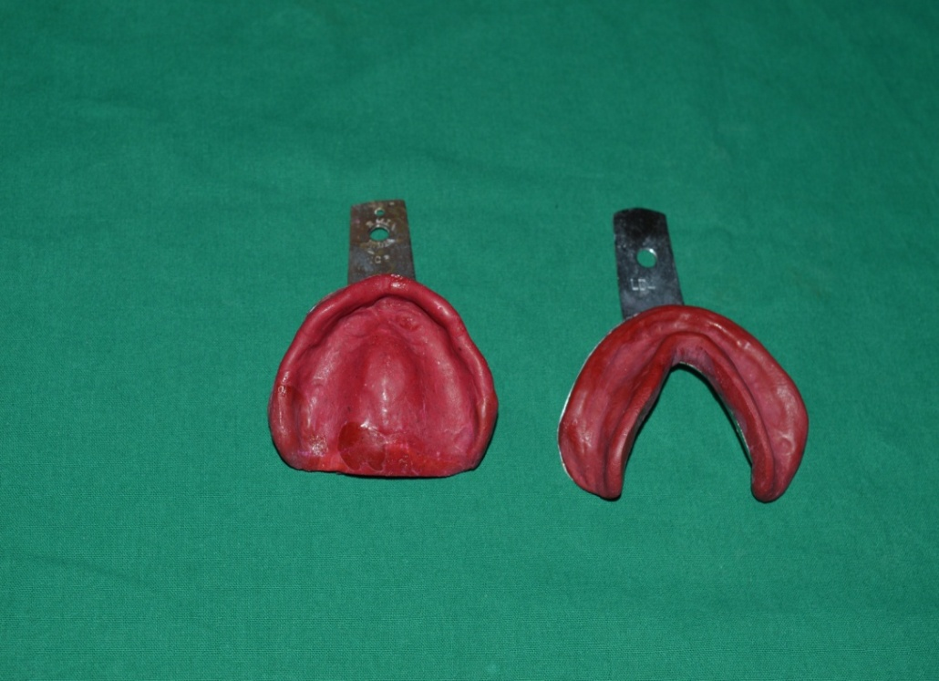  Prim Ary Impression  Prim Ary Casts | 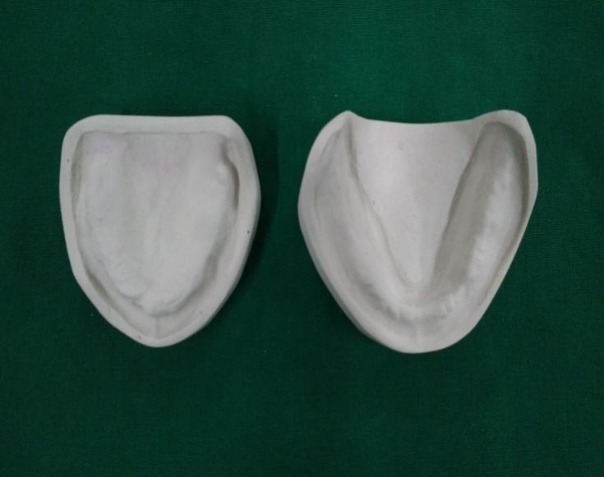
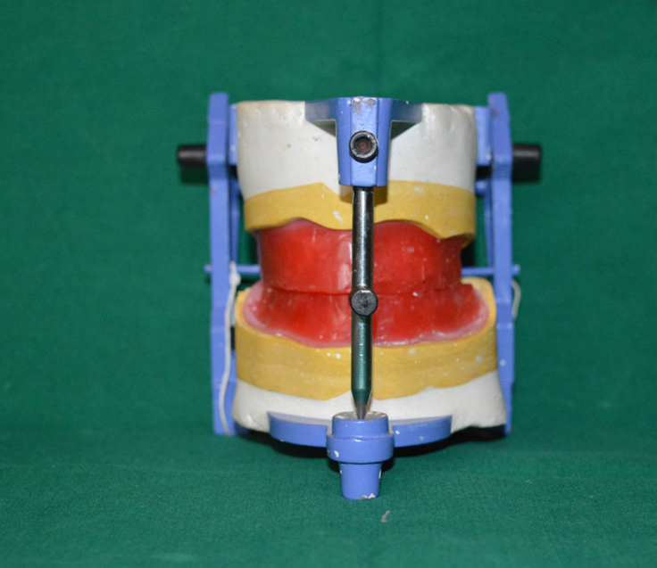  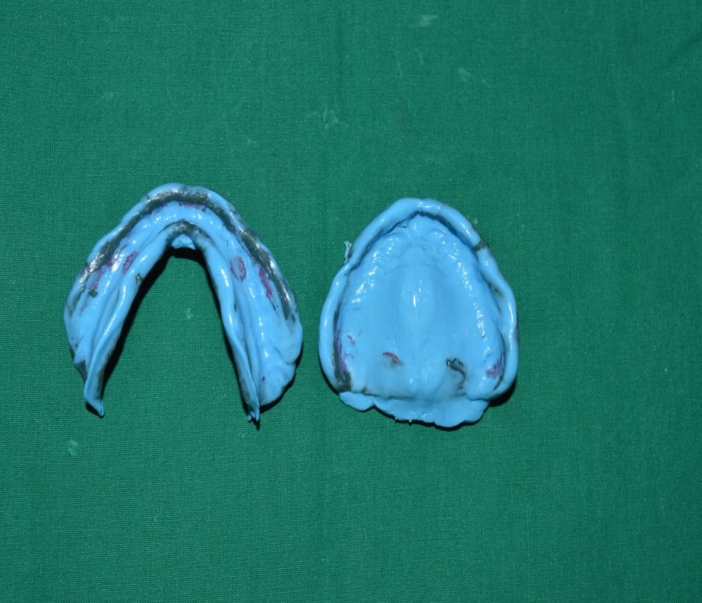  Jaw Relation Record Mounted On Articulator  Final Impression After Border Molding | 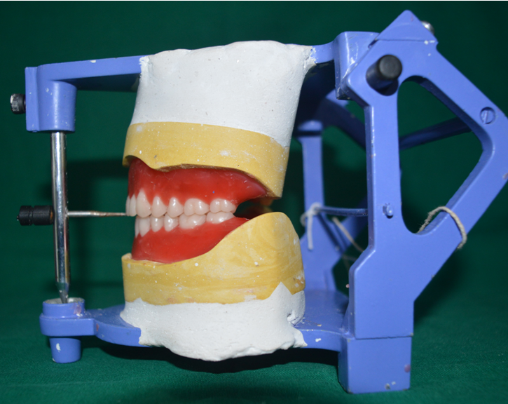  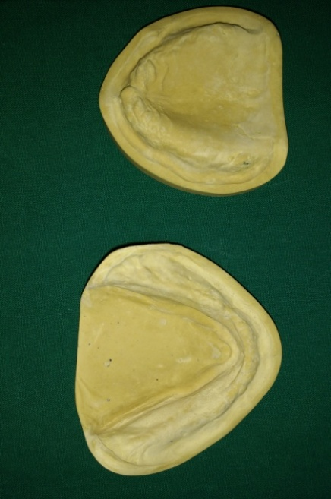  Trial Dentures After Try-In  Master Casts
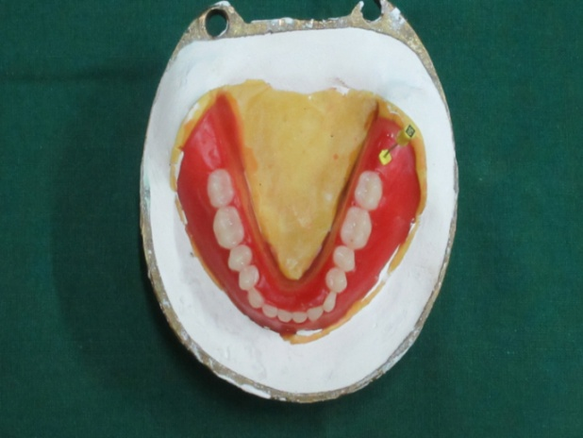  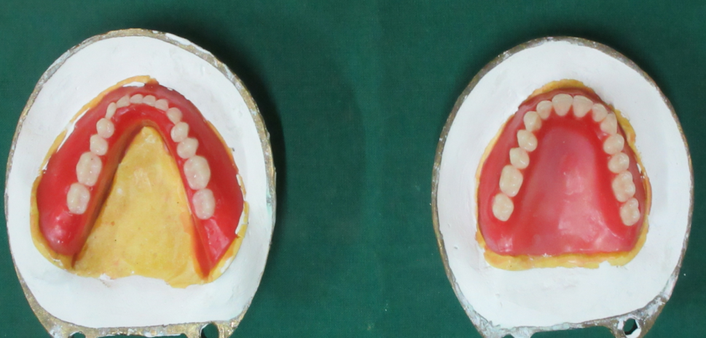  Flasked Trial Dentures | 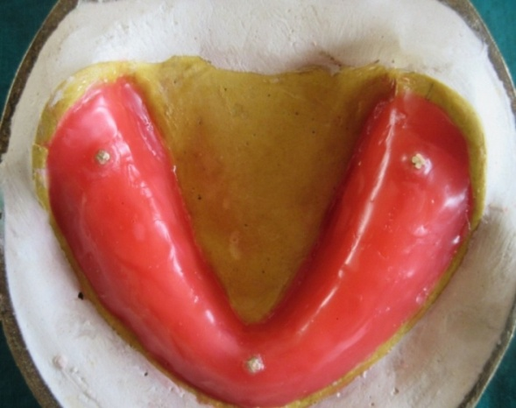

Final Mandibular Denture
Cured Clear Acrylic Reservoir Part Of Mandibular Denture Using Second Flask

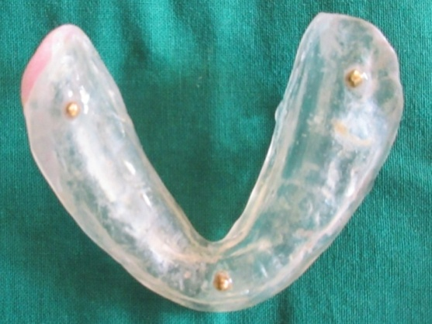  Before Creating Reservoir Space | 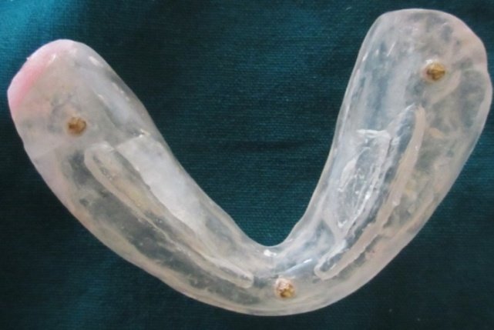  After Creating Reservoir Space
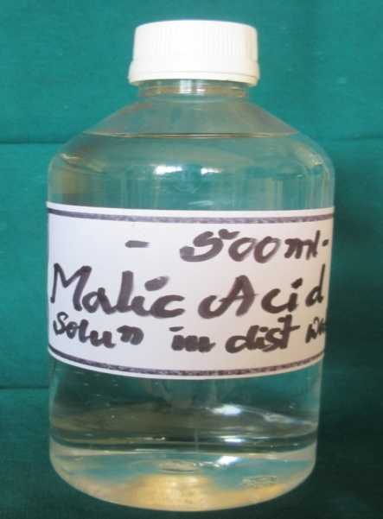  Sialogogue To Fill The Reservoir Space | 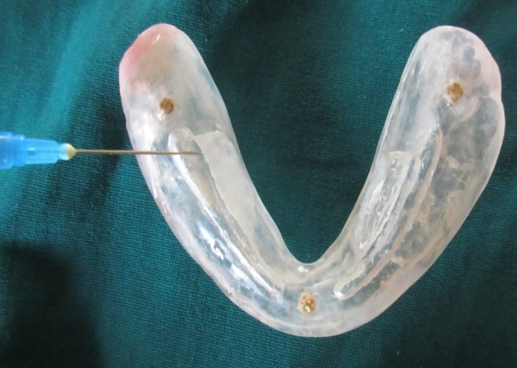  Filling Of Sialogogue Into The Reservoir Using Syringe
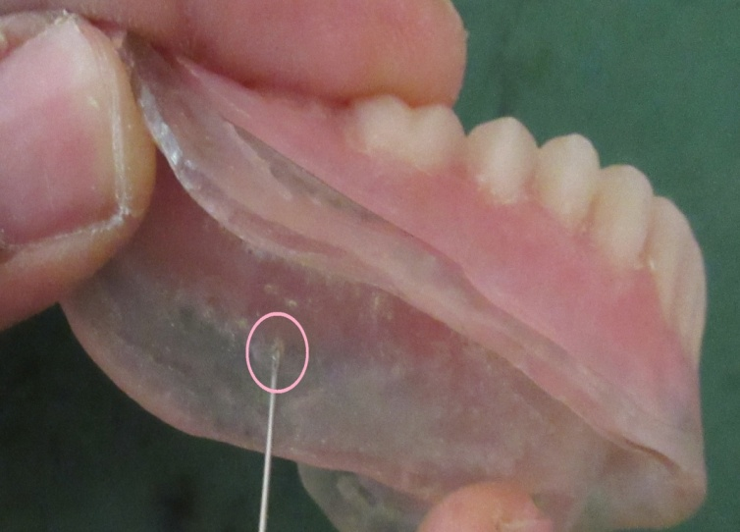  Draining Hole For The Sialogogue On The Tissue Surface Of Mandibular Lingual Flange  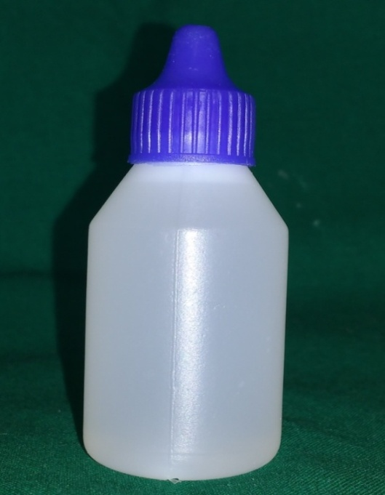 | 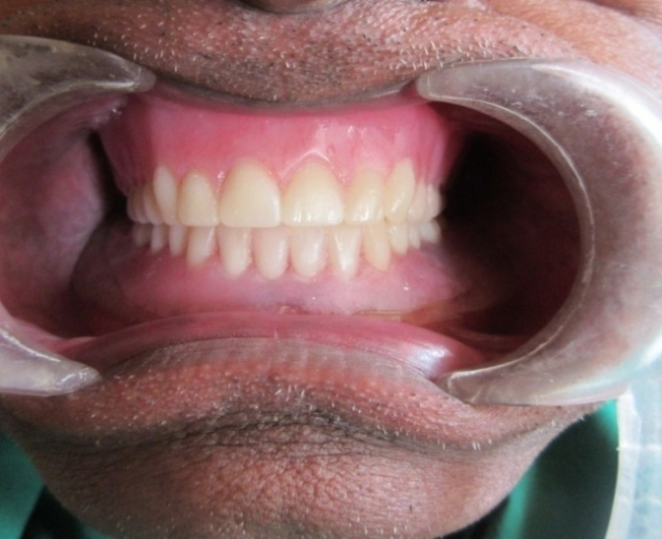  Intraoral View Of Maxillary And Mandibular Complete Dentures

Dispenser Provided To The Patient For Daily Use

Discussion
Saliva, exocrine secretion by salivary glands, is one of the most important components of stomagnathic system. Its decrease as in xerostomia lead to oral imbalance signs like increased caries, glossodynia, dysgeusia, halitosis, difficulties with speech, mastication, swallowing and wearing of intraoral prosthesis. Many approaches gradually evolved and prosthodontic management is one among them to manage xerostomia. One such prosthodontic management technique that is so simple and more convinent to dentist in fabrication was presented above.

Various techniques have been described in the literature to incorporate salivary reservoir in complete and partial dentures with their own advantages and disadvantages.

Agarwal et al⁵ and Burhanpurwala MA et al⁶ descibed a method of fabrication of salivary reservoir denture using snap button. The disadvantages of this technique eventhough tight snug fit that can be achieved using snap buttons are bulk of the prosthesis which affects speech and retention and also the snap buttons tend to corrode easily.
Modgi and Aras⁷ elucidated a technique of fabrication of salivary reservoir cast partial denture using precision attachment. Disadvantage of this technique is increased cost of the treatment.

Joseph AM et al² and Shah RM et al⁸ deviced a technique of fabrication of maxillary salivary reservoir complete denture. In this technique, they used flexible thermoplastic sheet to make reservoir lid. The advantages are snap fit of the lid and also corrosion resistant. The disadvantages are cumbersome technique, cannot be used in patients with high palatal vaults, need to preserve the working cast for fabrication of lid in future.

Bikash P and Seema P⁹ delineated a technique to fabricate split mandibular denture. The advantage is reservoir space was created priorly by placing clay. The disadvantages are time consuming, precision is essential and requires manual dexterity of the patient to refill the reservoir using syringe.

Lagdive SB et al¹⁰ contrived maxillary and mandibular complete dentures with salivary reservoir to a radiation induced xerostomia patient. The major disadvantages are precision is essential and manual dexterity of the patient is required in refilling the reservoir space.

Singh PP et al¹¹ gave maxillary salivary reservoir denture. In this, the lid was fabricated using resilient liner. It’s a functional type because the salivary substitute oozes out as the patient presses his tongue against the anterior portion of the palate. The lid was fixed to the denture base using autopolymerizing resin. The disadvantages are bulk of the prosthesis, cost of fabrication, difficulty in cleaning the reservoir and also in refilling the reservoir space.
Dabas N et al¹² and Mendoza AR et al¹³ put forward a technique in fabrication of split mandibular denture. The major disadvantages are duplication of master cast is required, fabrication of heat cure denture base prior to try-in, time consuming and requires precision.

Chatterjee A and Chatterjee D¹⁴ improvised the technique of fabrication of maxillary salivary reservoir denture. The reservoir lid was made of latex membrane. The advantages are no detachable parts, ease of replacement of latex membrane and relining is possible if needed. The disadvantages are cannot be used in patients allergic to latex and patient should take care while refilling the reservoir using syringe.

The major drawbacks of the presented technique are proper case selection with adequate interarch space and precision in fabrication is essential.

The advantages of the presented technique are 1% malic acid will act as sialogogue and increases salivary secretion without any harm whereas in above mentioned techniques salivary subtitute was used to fill the reservoir space, duplication of the master cast is least needed, one mean value articulator is sufficient, die pins are economical and easily available, ease of cleansibility and less manual dexterity to refill the reservoir space.

Conclusion
Xerostomia is more common symptom among elderly population and often overlooked. Careful diagnosis and proper management plays vital role in xerostomia patients especially in elder age. As that will increase patient compliance and comfort to wear any prosthesis which in turn can improve the quality of life..

References
- Bhushan P et al. Salivary reservoir designs for patients with xerostomia: A Review. Journal of Research in Dentistry 2016; 4(2):51-57.
- Joseph AM et al. Functional salivary reservoir in maxillary complete denture – technique redefined. Clinical Case Reports 2016; 4(12):1082-1087.
- Tanasiewicz M, Hildebrandt T, Obersztyn I. Xerostomia of various etiologies: A review of the literature. Adv Clin Exp Med 2016; 25, 1, 199-206.
- Zarb GA, Bolender CL, Eckert SE, Fenton AH, Jacob RF, Mericske-Stern R. Prosthodontic treatment for edentulous patients. 12th ed. St. Louis: Mosby; 2004. p. 25.
- Agrawal KK, Singh SV, Rashmikant US, et al. Prosthodontic rehabilitation in Sjogren's syndrome with a simplified palatal reservoir: Two year follow up. J Prosthodont Res 2011;55:248-51.
- Burhanpurwala MA, Magar SK, Bhandari AJ, et al. Management of an edentulous patient having xerostomia with artificial saliva reservoir denture. J Ind Prosthodont Soc 2009;9:92-5.
- Modgi CM, Aras MA. An innovative design of 2-piece saliva reservoir using precision attachment: a case report. J Indian Prosthodont Soc 2012;12:260-3.
- Shah RM, Aras MA, Chitre V. An innovative and simple approach to functional salivary reservoir fabrication. J Prosthodont 2014;00:1-4.
- Pattanaik B, Pattanaik S. Prosthetic rehabilitation of a xerostomia patient with a mandibular split salivary reservoir denture. Ann Essenc Dent 2010;2:30-3.
- Lagdive S B et al. Dentures As Artificial Saliva Reservoirs In The Irradiated Edentulous Cancer Patient With Xerostomia. Indian Journal of Basic & Applied Medical Research. December 2011; 1(1):31-37.
- Singh PP et al. Prosthodontic rehabilitation of salivary gland hypofunction with artificial salivary reservoir in complete denture. Journal of Advanced Medical and Dental Sciences Research. 2014;2(1).
- Dabas N, Phukela Dabas N, Phukela SS, et al. The split denture: managing xerostomia in denture patients. A case report. Indian Prosthodont Soc 2011;11:67–70.
- Mendoza AR, Tomlinson MJ. The split denture: a new technique for artificial saliva reservoirs in complete denture. Aust Dent J 2003;48:190-4.
- Chatterjee A and Chatterjee D. False Palate Reservoir Denture – A Novel Technique. IOSR Journal of Dental and Medical Sciences 2014. 13(1):05-09.

